WEED DETECTION

Submitted by

SAYAN DAS (13000117053)

SAYAK DAS (13000117054)

SATYAKI SETT (13000117055)

NILAY CHOWDHURY (13000117083)

Submitted for the partial fulfillment for the degree of Bachelor of Technology in Computer Science and Engineering



Techno Main Salt Lake,

EM 4/1, SaltLake, Sector V, Kolkata – 700 091

Contents

1. INTRODUCTION 7

1.1 ABSTRACT 7

1.2 PROBLEM STATEMENT: 8

1.3 RELATED STUDIES: 9

1.4 GLOSSARY 10

2 STUDY FINDINGS 11

2.1 STUDY COVERAGE: 11

2.2 SOLUTION ALTERNATIVES 12

2.3 RECOMMENDATION 13

2.4 REQUIREMENTS 14

2.5 PROTOTYPING: 15

3 CONCLUSION 17

4 REFERENCES 18

# Introduction

## Abstract

This section should be within 600-800 characters including spaces. Considering your project, ensure to state the following: project purpose: 1 line (which can be understood by anyone), detailed and specific purpose: 1 or 2 lines (specific to CSE), problem statement: 2 or 3 lines (specific to CSE), solution and expected results: 2 or 3 lines (specific to CSE) and project benefits: 1 line (should be understood by anyone).

## Problem Statement

State the problem you have studied for exploring possible solutions. For clearing the project boundaries, specify your scope, exclusions and assumptions.

## Related Studies

State your related studies showing connections to your specific problem to be solved. For avoiding plagiarism, please avoid direct copy of texts, rather write in your own language and use citations for all referred texts particularly here and other parts of the document using appropriate numbers within square bracket for all mapped references under applicable section on references.

Ensure to check any standard journal / IEEE paper for seeing sample related studies and usage of citations and references.

## Glossary

State the acronyms used in this document and their expansions in a tabular format.

# Study Findings

## Study Coverage

Provide a tabular representation of items you have studied and brief purpose with a goal to solve your specific problem.

## Solution Alternatives

State the available options and their features for solving the problem under your study.

## Recommendation

State your chosen path to solve the problem citing cost-benefit analysis of solution alternatives. For helping in your understanding, your chosen path after this detailed study will be treated as your project for working in the next 2 semesters:

i) Analyze the requirements and design preferably with a prototype / mini-solution / proof-of-concept (under 7th semester)

ii) Develop the full solution (under 8th semester).

## Requirements

List the requirements for implementation using a tabular format with SL, Requirement, Purpose in a line and Prototype flag. Simply put, requirement means: “What are the functions / features needed in the solution / system?” This requirement matrix will be the basis of your upcoming project in 7th and 8th Semester.

## Prototyping

Have you worked on a mini solution or proof-of-concept even as a part of your current studies? If yes, ensure to mark Prototyping flag for specific requirements under above specific table. Ensure to present your prototype as a part of your viva presentation.

# Conclusion

State the summary of the work done and your specific conclusions from your detailed studies. Justify your upcoming project in terms of project benefits for future analysis, design and development over next 2 semesters.

# References

State the full list of references under this section. Please follow a standard journal / IEEE paper for preparing this section.

# APPENDIX A – Additional relevant information

Keep this appendix only if it is required, remove otherwise. Modify the appendix name as per your need.

# APPENDIX B – Listing of your published papers

Keep this appendix only if it is required, remove otherwise.

# APPENDIX C – More Instructions for filling this template

**Remove the following instructions after your report is completed:**

1. For avoiding plagiarism, citations should be used for all referred texts using appropriate numbers within square bracket for all mapped references under application Section on References. You should check any standard journal / IEEE paper for typical use of citations.
2. **Double-click inside the page header and replace “Project Title” text with your specific project title. Obviously, you should also process the same on the cover page.**
3. For Table of Content (TOC), default Font Size=12. If the TOC is not fitting in a single page, you should select it and try with a reduced size.
4. After TOC, please use the following uniformly for your documentation: Font Style=”Times New Roman”, Font Size=”12” and Alignment=”Justified..
5. Team should perform reasonable numbers of proof reading for avoiding unintentional errors and factual discrepancies before uploading or submitting teh documents.
6. For all figures, captions should be bold with centrally aligned and should be positioned below the figures, e.g.



Using MS-Word features, insert figures and tables after they are cited in the text so that they can automatically come after inserting / updating TOC.

1. Use a text box to insert a graphic (which is ideally a 300 dpi TIFF or EPS file, with all fonts embedded) because, in an MS Word document, this method is somewhat more stable than directly inserting a picture.
2. To have non-visible rules on your frame, use the MSWord “Format” pull-down menu, select Text Box > Colors and Lines to choose No Fill and No Line.
3. For all tables, captions should be bold with centrally aligned and should be positioned above the tables, e.g.

**Table 1: Sample Table**

| Table Head | Table Column Head | | |
| --- | --- | --- | --- |
| Table column subhead | Subhead | Subhead |
| Copy | More table copya |  |  |

a. Sample of a Table footnote. (Table footnote)

1. If you have published related paper(s) in a standard journal / presented in a recognized conference, please ensure to refer the same under Section on References. For such cases, you should also paste communication on your paper(s), acceptance / publishing notes under the Appendix section. You should also show appropriate documentation at the time of your evaluations.
2. Depending on the type of your project, sections can be altered to this generic template.

# 1. INTRODUCTION

## 1.1 ABSTRACT

The project deals with identification of weed in dedicated agricultural field. We will be using machine learning to check the presence of weed in an agricultural field so that it can be removed to ensure no further draining of nutrition.

In an agricultural land, weeds drain in the nutrition from the ground and the application of weedicides can hamper the fertility of the field. The only way to detect these weeds is by human interaction. We are looking for a model that will detect weeds.

We are looking forward to create a model using computer vision to detect weeds without human interaction. Our idea is to capture image in agricultural field, process the images and determine if any other plants other than the target plant of the field is present in that frame or not.

Project benefit:

* If the weeds are removed than the whole nutrition of the soil will be fed to the main plant.
* Since the weeds will be removed, no weedicides will have to be used so the fertility will remain intact.

## 1.2 PROBLEM STATEMENT:

Agriculture in India plays a significant part in employing more than 50% of the Indian workforce and contributing around 18% to the country’s GDP.

Due to the semitropical nature of the land pests and weeds are significant threat to our crops leading to droughts, famine and most importantly suicides of farmers.

Weeds drain in the nutrition from the ground and prevalent weedicides are often rendered incapable of removing these threats due to their evolution. This affects the production of the crops and also reducing the quality of the fodder and the land itself.

## 1.3 RELATED STUDIES:

Machine vision system for weed detection using image filtering in vegetable crops. [[1]](http://www.scielo.org.co/scielo.php?script=sci_arttext&pid=S0120-62302016000300124)

Digital image processing techniques for detecting, quantifying and classifying plant diseases. [[2]](https://springerplus.springeropen.com/articles/10.1186/2193-1801-2-660)

Weed detection using image processing. [[3]](https://www.irjet.net/archives/V3/i3/IRJET-V3I3260.pdf)

Objects Talk - Object detection and Pattern Tracking using TensorFlow. [[4]](https://ieeexplore.ieee.org/abstract/document/8473331)

Weed detection using image processing under different illumination for site-specific areas spraying. [[5]](https://www.sciencedirect.com/science/article/pii/S0168169915003981)

## 1.4 GLOSSARY

Target plant: The plant is grown in a particular field . For demonstration purpose, we have considered potato plants as our target plant.

# 2 STUDY FINDINGS

## 2.1 STUDY COVERAGE:

|  |  |
| --- | --- |
| Research Paper | Features |
| 1[[1]](http://www.scielo.org.co/scielo.php?script=sci_arttext&pid=S0120-62302016000300124) | 1. From this paper, we got to know about the flowchart of image processing using computer vision. 2. The whole detection algorithm in this paper is based on area covered by the green plant. Hence it is detecting all the small plants as weeds and all the comparatively bigger plants as non weeds. Moreover, this research work didn't use machine learning to train any data on weeds. |
| 3[[3]](https://www.irjet.net/archives/V3/i3/IRJET-V3I3260.pdf) | 1. In this paper, the weeds are classified into two types:   (i) Weeds with narrow leaves  (ii) Weeds with wide leaves   1. To detect weeds, the model in this paper uses edge detection. 2. Once edge detection takes place, it is then checked if the edge appears within the weed frequency range and then it is divided into blocks of certain size. |
| 4[[4]](https://ieeexplore.ieee.org/abstract/document/8473331) | 1. The model in this paper uses object detection and pattern analysis using TensorFlow, which determines any object based on its size, shape and texture. |
| 5[[5]](https://www.sciencedirect.com/science/article/pii/S0168169915003981) | 1. The algorithm depends a lot on the weather status (sunny, cloudy) of that day. 2. The images are needed to be converted into grayscale. |

## 2.2 SOLUTION ALTERNATIVES

* Referring to point 2 from the above, we could have used this algorithm which is based on area covered by the green plant, but this algorithm does not include any learning algorithm. Hence, the dataset cannot be trained.
* Referring to point 4 from the above, we could have used edge detection but did not use this since it uses edge detection which may lead to data loss in comparison to the normal image.
* Referring to point 7 and 8 from the above, we could have used this detection model but it depends on weather status and the conversion of image into grayscale may cause data loss.

## 2.3 RECOMMENDATION

With this project we are aiming to detect weeds, but there are a huge different sets of weeds which will lead to huge dataset and also may require different algorithms in ML. And moreover it will exert immense pressure on the training and testing procedures with scattered outputs.

Thus, we have decided to detect the plants of agricultural field rather than weeds, such that everything else remaining other the plant is considered to be weed.

We are using object detection algorithm from TensorFlow, to detect the target plants.

But such a dataset of high magnitude is not available and Google images may lead to lower accuracy due to different qualities. Thus we have to create our own dataset of plant images by visiting agricultural fields.

## 2.4 REQUIREMENTS

|  |  |  |  |  |
| --- | --- | --- | --- | --- |
| SL | Requirement | | Purpose | Prototyping Flag |
| 1. | Dataset of 500 labeled pictures | | The dataset will be used to perform the training and testing operation. |  |
| 2. | Pre-trained model to apply transfer learning (SSD MobileNet v1) | |  |  |
| 3. | Programming Language:  Python3 | |  |  |
| 4. | Image Labeling tool: Labellmg | | It is used to label pictures |  |
| 5. | Dependencies | numpy | **NumPy** is a **python** library used for working with arrays. It also has functions for working in domain of linear algebra, fourier transform, and matrices. |  |
| six | **Six** is a Python 2 and 3 compatibility library. It provides utility functions for smoothing over the differences between the Python versions with the goal of writing Python code that is compatible on both Python versions. |  |
| TensorFlow | **TensorFlow** is an open source software library for dataflow and differentiable programming across a range of tasks. We will be using Object detection algorithm from TensorFlow. |  |
| matplotlib | **Matplotlib** is a comprehensive library for creating static, animated, and interactive visualizations in Python. |  |
| pillow | **Pillow** is a free and open-source additional library for Python that adds support for opening, manipulating, and saving many different image file formats. |  |
| Object_detection | Object detection is the python Package that comes with TensorFlow and consists of all necessary tools for object detection and training of a TensorFlow model, generating inference graph and testing of generated model. |  |
| Opencv-python | It is open source python library to handle images and videos from both camera and computer memory. |  |

## 

## 2.5 PROTOTYPING:

We have considered potato plant as our target plant, so all other plants are considered as weeds.

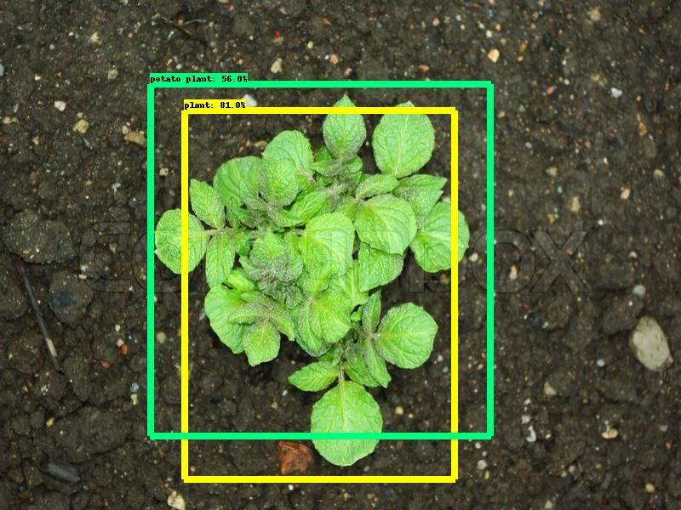

**Figure 1**

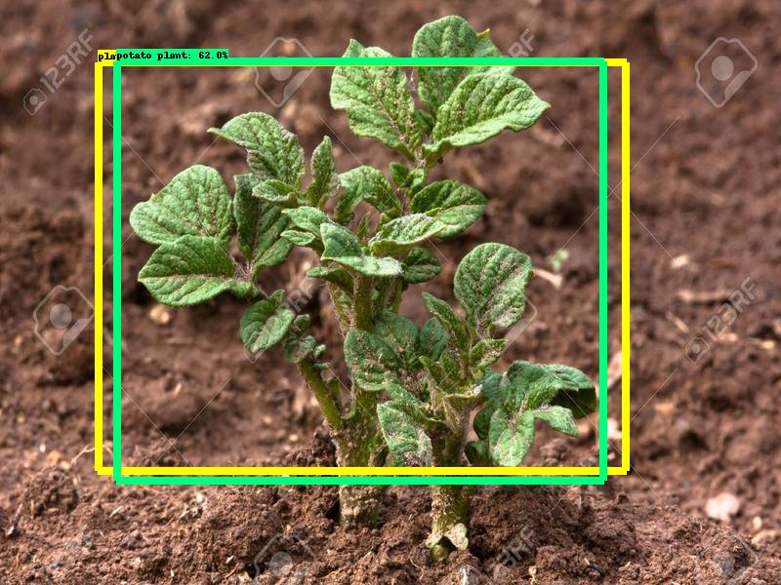

**Figure 2**

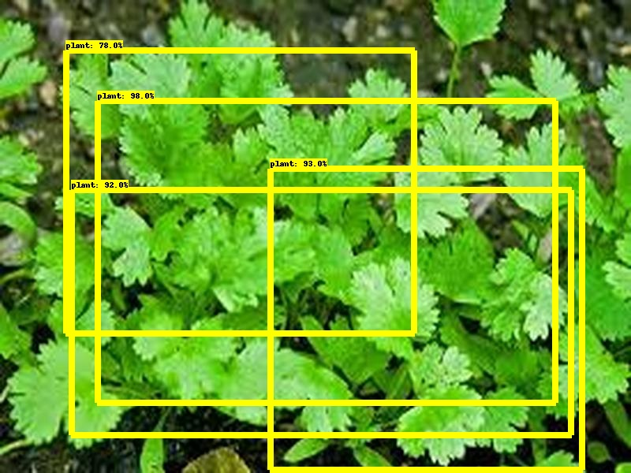

**Figure 3**

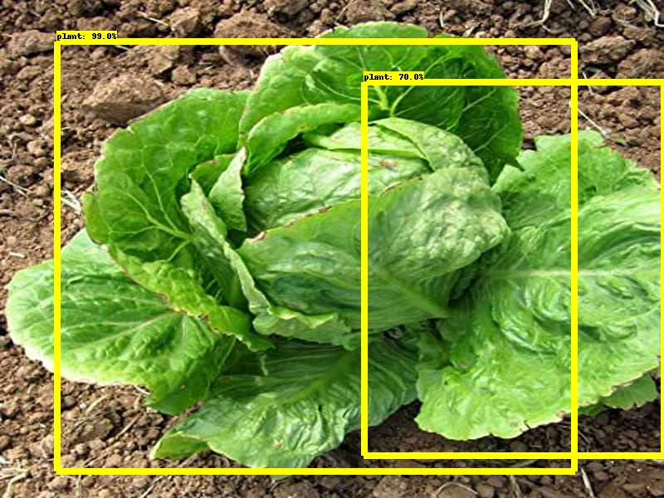

**Figure 4**

From the above demo, we can see that pictures of potato plants(Figure 1 and figure 2) are detected as “**potato plants**”, but pictures of all other plants(Figure 3 and figure 4) are detected as just ”**plants**”.

# 3 CONCLUSION

# 4 REFERENCES

* [Machine vision system for weed detection using image filtering in vegetable crops.](http://www.scielo.org.co/scielo.php?script=sci_arttext&pid=S0120-62302016000300124)
* [Digital image processing techniques for detecting, quantifying and classifying plant diseases](https://springerplus.springeropen.com/articles/10.1186/2193-1801-2-660).
* [Weed detection using image processing.](https://www.irjet.net/archives/V3/i3/IRJET-V3I3260.pdf)
* [Objects Talk - Object detection and Pattern Tracking using TensorFlow.](https://ieeexplore.ieee.org/abstract/document/8473331)
* [Weed detection using image processing under different illumination for site-specific areas spraying](https://www.sciencedirect.com/science/article/pii/S0168169915003981).
* [Training Custom object detector](https://tensorflow-object-detection-api-tutorial.readthedocs.io/en/latest/training.html)